Installing Java 3d Package on Ubuntu Systems

For the Java 3d API to be working on Ubuntu Systems, we need Java to be present.

First, update the package index:

sudo apt-get update

Then Check whether Java is installed or not:

java -version
If Java is present it will show this:

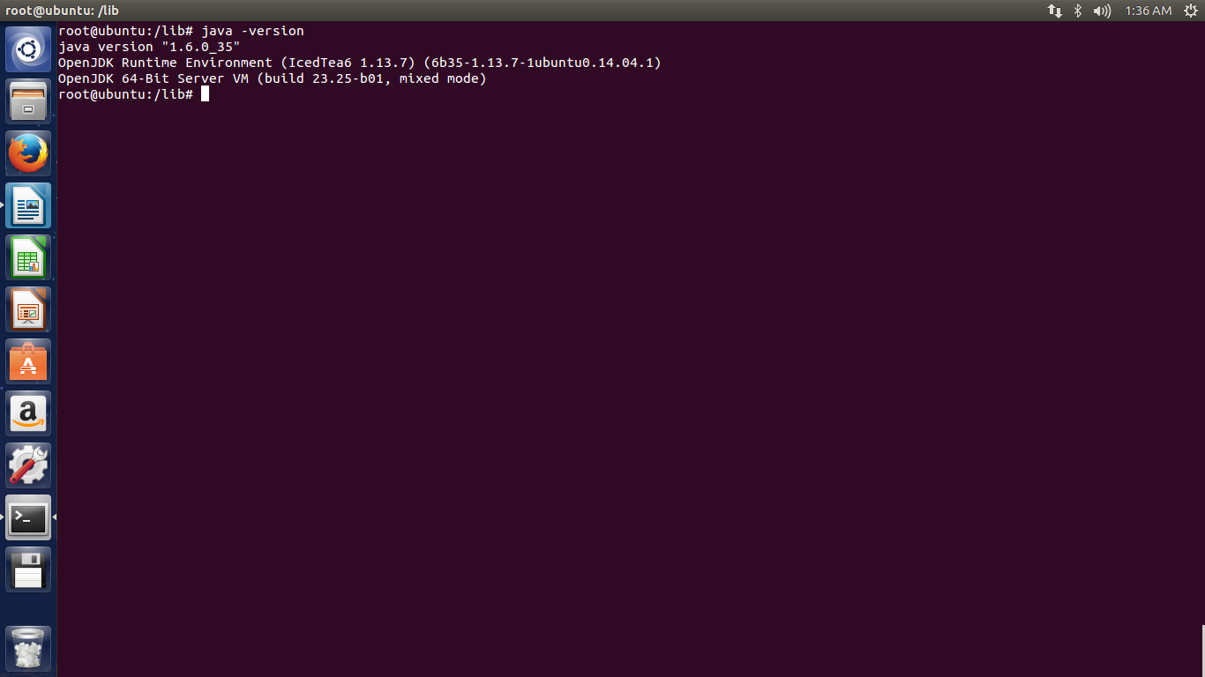

If it is not present it will show this:

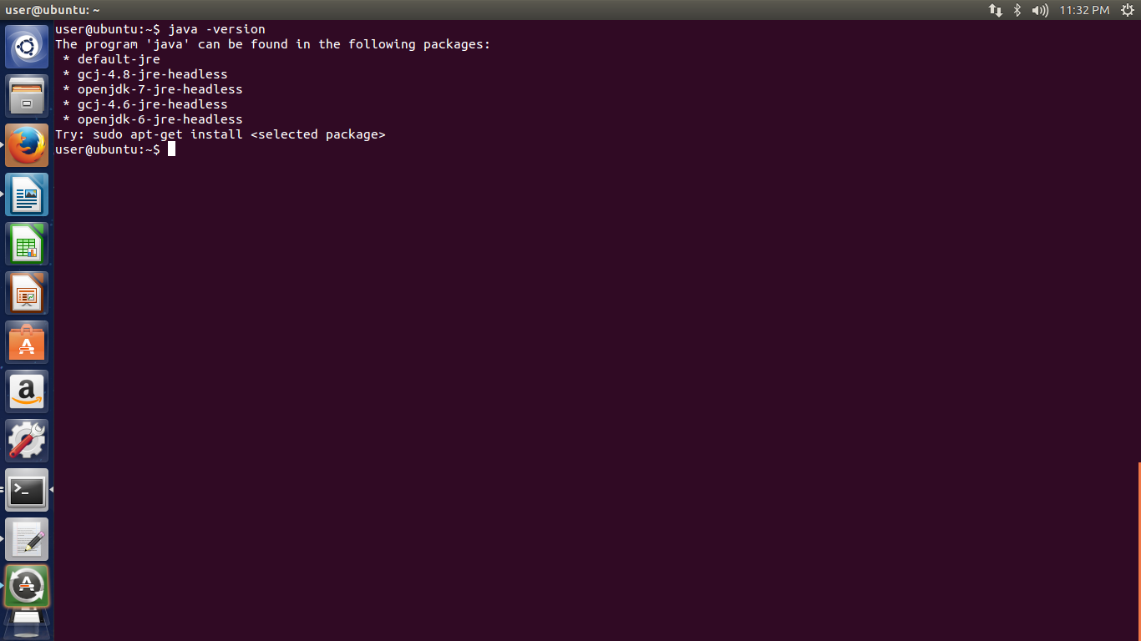

To install Java we can execute the following command:

sudo apt-get install openjdk-6-jre openjdk-6-jdk

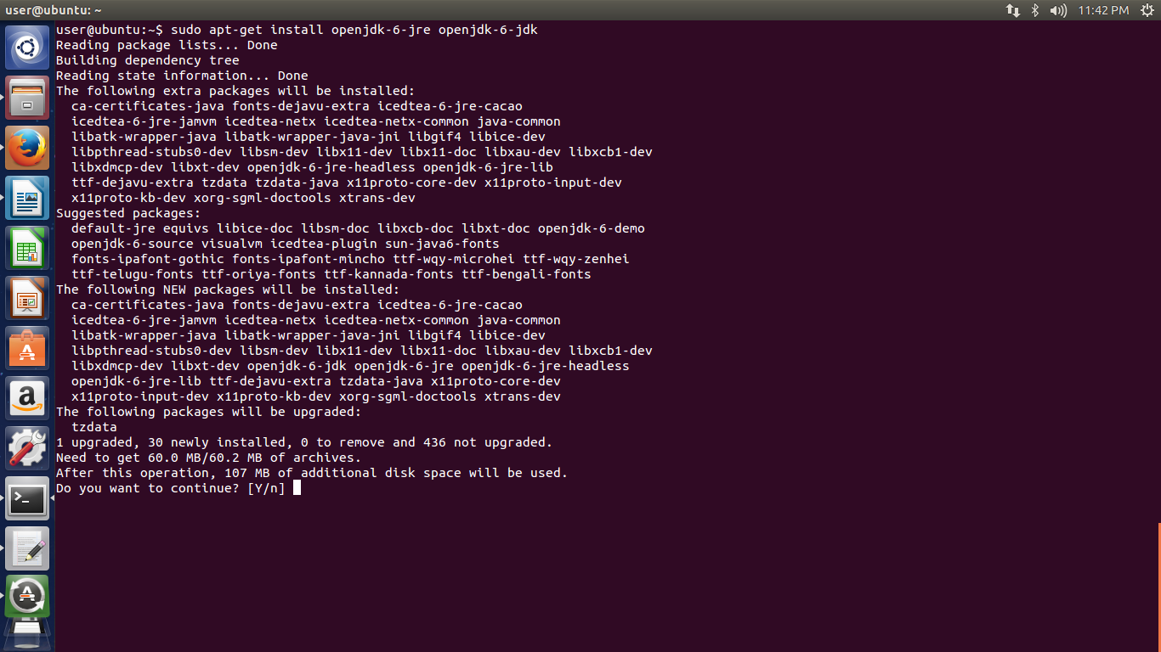
You will get a prompt such as this: Enter Y

This command will install Java RunTime Environment(JRE) and Java Development Kit(JDK).
Check the java version with the command
java -version

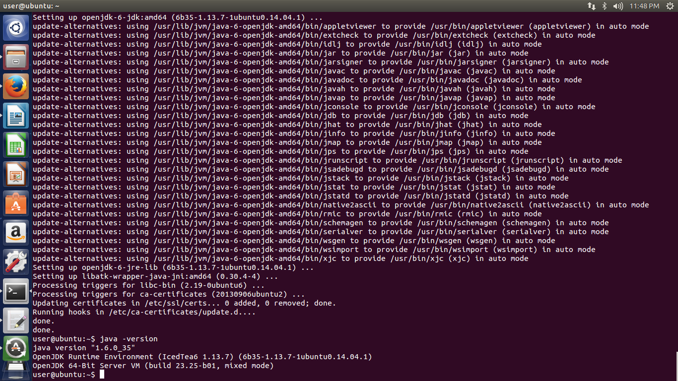
It is also important to install the wrapper for running JAVA applets on browser: Iced Tea Java Plugin.
Type the following command in the terminal:

sudo apt-get install icedtea-6-plugin

After installing these packages, now set the environment variables.

Type the following command in the terminal:

sudo gedit /etc/profile

After authenticating, add the following lines in the end of the file.

JAVA_HOME=/usr/lib/jvm/java-6-openjdk-amd64
PATH=$PATH:$HOME/bin:$JAVA_HOME/bin
export JAVA_HOME
export JRE_HOME
export PATH

The File will look like this after inputing the above lines.
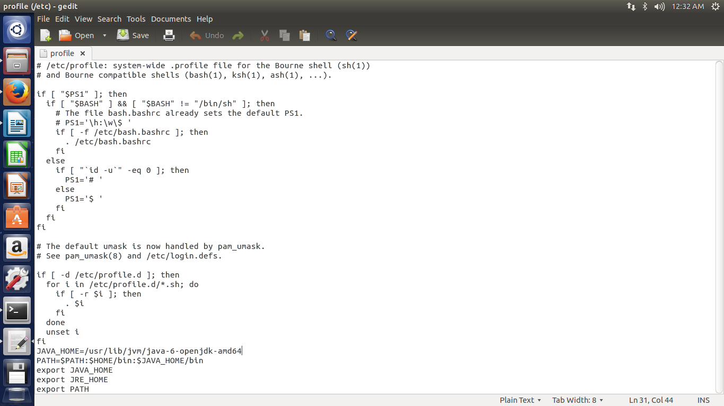
After this, we need to install Java 3d api and configure it's path.
Install The package from the site: https://java3d.java.net/binary-builds.html

Download and unzip j3d-1_5_2-XXX.zip into a temporary download directory, for example, /tmp.

This will create a j3d-1_5_2-XXX subdirectory in /tmp where the downloaded files can be found. The file you need for manual installation is j3d-jre.zip.

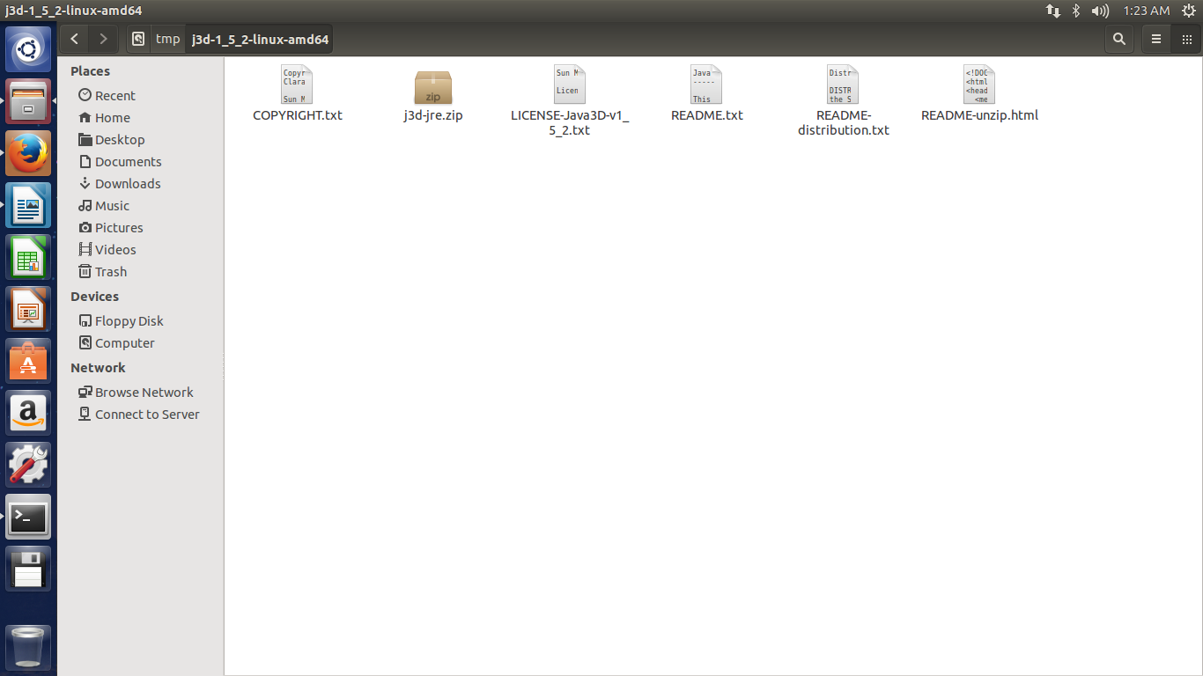

Create a folder for the j3d jar files and native libraries, for example, /myhome/j3d, and unzip j3d-jre.zip into this directory as follows:

cd /myhome/j3d
unzip /tmp/j3d-1_5_2-*/j3d-jre.zip

Modify your CLASSPATH environment variable to include the full paths to j3dcore.jar, j3dutils.jar, and vecmath.jar. For example:

export CLASSPATH=.:/myhome/j3d/lib/ext/j3dcore.jar:/myhome/j3d/lib/ext/j3dutils.jar:/myhome/j3d/lib/ext/vecmath.jar

Modify your LD_LIBRARY_PATH environment variable to contain the full path to the lib/<ARCH> directory. For example, on 64-bit Linux:

export LD_LIBRARY_PATH=/myhome/j3d/lib/amd64

